**Create Auth0 Account**

<http://auth0.com>

As part of the signup process you’ll be asked to create an Application.

Enter a domain name that is unique to you, perhaps: janesmith-24hrvideo.auth0.com

Open the auth0 dashboard, click on “Applications” in the left-hand menu.

Select the application you just made, most likely called “Default app”

The settings pages will open.

Scroll down until you find the textbox called “allowed origins (CORS)”. Enter that your web site is running from: <http://localhost:8100>

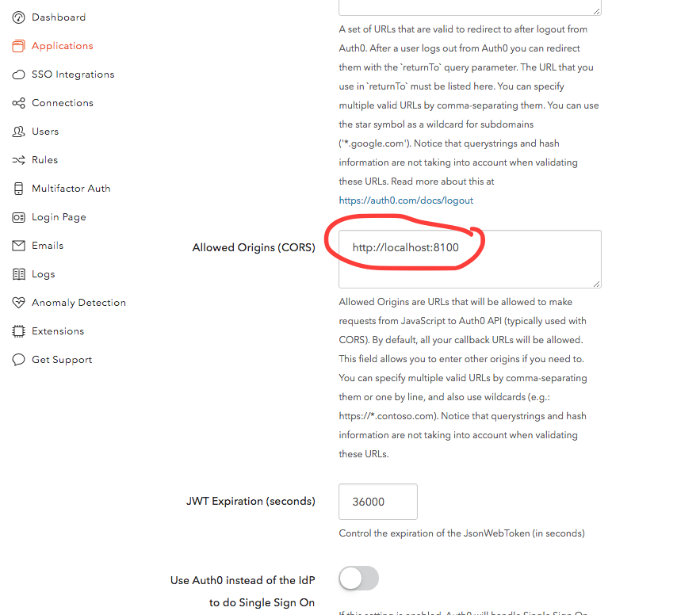

Scroll down and hit the “Save Changes” button

**Get the domain & client ID settings for your application**

We now need to retrieve the domain & client ID values and inject them into our web-site’s code. On the same settings page, scroll up until you find the ‘Domain’ and ‘Client ID’ values:

